

MARKETING PACK

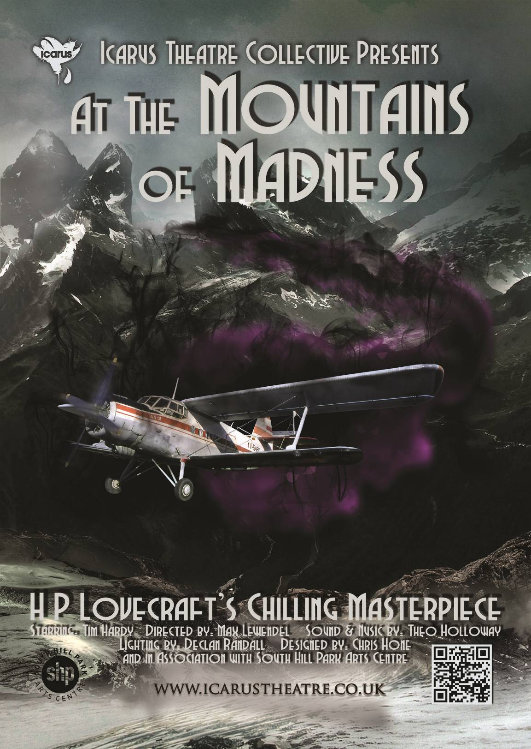
TOURING INTERNATIONALLY
January 2016 – December 2017
Contents:

- Sample Press Release (3)
- Print & Online Copy (4)
- Editors information (5)
- Biographies (6)
- Reviews (11-15)
- Past Shows (16-21)
MEDIA RELEASE: TOURING 2016 – THEATRE – At the Mountains of Madness
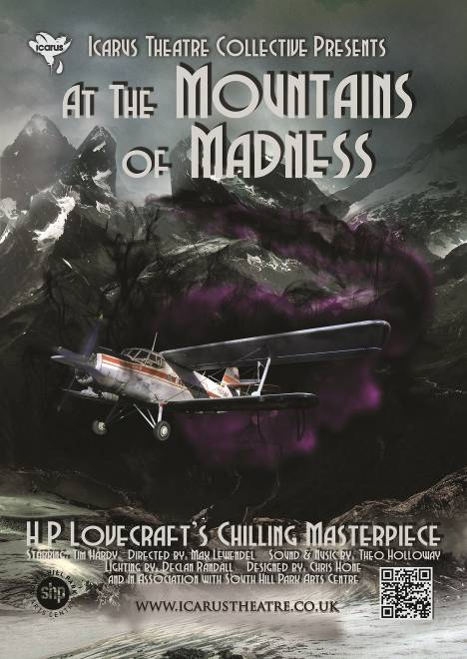
Icarus Theatre Collective presents Tim Hardy in
At the Mountains of Madness
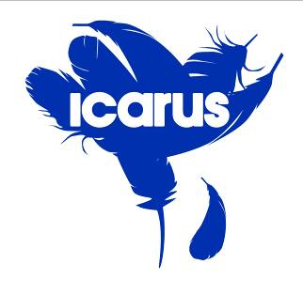
by HP Lovecraft
Starring Tim Hardy

World Premiere
International Tour

YOUR VENUE
DATA
HERE

Icarus Theatre Collective brings you a World Premiere, the first theatre adaptation of H.P. Lovecraft’s chilling masterpiece “At the Mountains of Madness.” William Dyer is brought vividly to life, trapped and tormented by visions of what he saw – and what he could not possibly have seen – in those ancient, Antarctic mountains of madness.
For nearly a century, this cornerstone of Weird fiction has thrilled readers with its tale of a disastrous expedition to Antarctica, and the awful implications of what was discovered.
After their successful collaboration on The Trials of Galileo touring Malta, Spain, the Edinburgh Fringe, America, and the UK, RSC actor and RADA faculty Tim Hardy rejoins the collective for his 50th year working in the industry as the leader of the ill-fated expedition, offering theatre audiences a masterclass in acting.
Estimated Running time: 1h10m (1h30 incl interval)
Press on Tim Hardy in
The Trials of Galileo:
Wandsworth Radio
Fringe Review
Edfringe.com
The Public Reviews
Remotegoat
Fringe Guru
View from the Gods
British Theatre Guide
Broadway Baby
Three Weeks

"Icarus Theatre fly into London on waxen wings which show no sign of melting any time soon".
-Remotegoat

Born in Rome, Tim Hardy was educated at St. Paul’s School, London. Early on he played the title role in Comus by John Milton before Her Majesty the Queen and His Royal Highness the Duke of Edinburgh leading to him winning a place at the Royal Academy of Dramatic Art (RADA) with a scholarship.

Television credits include the title role in Galileo and Arthur Taylor in Oscar Wilde opposite Sir Michael Gambon for the BBC, Jesus in Son of Man, John Rampayne in The Trial of Sir John Rampayne opposite Sir Ian McKellen, The Doctor in The Wife of Bath opposite Julie Walters, David Manners in Eastenders, leading roles in Midsomer Murders, Rabbi in Casualty 1909, and Ross in Macbeth. Films credits include Captain Corelli’s Mandolin, The Duelist, Nothing but the Best, and Marat\Sade.
Company Website: www.icarustheatre.co.uk

For further information, interviews, press tickets or images contact
Max Lewendel (pr@icarustheatre.co.uk or 0207 998 1562)

PRINT & ONLINE COPY /

Title:
H.P. Lovecraft’s At the Mountains of Madness

Please use the author’s name in the title if at all possible. This is a major selling point. If there isn’t room, use just “At the Mountains of Madness” but make sure to mention the author in the copy used beneath it.

107 Word Copy:

Desperate. Incensed. Exhausted. William Dyer returns from a cursed expedition to the Antarctic.

To protect our world, he keeps deep secrets that he knows the speaking of can only shatter his fragile mind. But as he comes to the realisation that we, the audience, are planning to go further into the penetrating cold than he dared, will his secrets unfold? Will he finally be resigned to speak? Will he share the truth, and give us terrifying glimpses of – the horror of things that should not be?

Be drawn into the untold world of the Antarctic, and stumble upon unnameable horrors that lie beyond The Mountains of Madness.

133 Word Copy:

Icarus Theatre Collective brings you a World Premiere, the first theatre adaptation of H.P. Lovecraft’s chilling masterpiece “At the Mountains of Madness.” William Dyer is brought vividly to life, trapped and tormented by visions of what he saw – and what he could not possibly have seen – in those ancient, Antarctic mountains of madness.
For nearly a century, this cornerstone of Weird fiction has thrilled readers with its tale of a disastrous expedition to Antarctica, and the awful implications of what was discovered.

After their successful collaboration on The Trials of Galileo touring Malta, Spain, the Edinburgh Fringe, America, and the UK, RSC actor and RADA faculty Tim Hardy rejoins the collective for his 50th year working in the industry as the leader of the ill-fated expedition, offering theatre audiences a masterclass in acting.
EDITOR’S NOTES /

Icarus Theatre Collective

Icarus is unique as a mid-scale theatre company in that it functions as a collective. A team of highly qualified Producers lead the company under the measured Artistic Direction of company founder Max Lewendel. Each Producer acts part-time on each project and has set tasks and responsibilities. In this way many projects can happen simultaneously and the company maintains a clear, strong Artistic Vision. Once per year, each producer leads one major project. This can be a play, a tour, a major education project, a devised piece, virtually anything approved by the Collective. They act full time for the duration and have a team of part time staff made up of the other Producers in the collective with clearly defined roles.
BIOGRAPHIES /

Tim Hardy – William Dyer / Co-Adapter

Born in Rome, Tim was educated at St.Paul’s School, London. Early on he played the title role in Comus by John Milton before Her Majesty the Queen and His Royal Highness the Duke of Edinburgh leading to him winning a place at the Royal Academy of Dramatic Art (RADA) with a scholarship.

Since graduating work for the Royal Shakespeare Company includes Henry V directed by Sir Peter Hall and Marat\Sade directed by Peter Brook and played on Broadway before being turned into a feature film. Work in the West End includes Hotspur in Henry IV and Dauphin in Henry V opposite Tim Dalton, The Spartan in Lysistrata directed by Sir Peter Hall, Alan in Mary Barnes opposite Simon Callow, and Perchik in Fiddler on the Roof. Off West End he played the title role in Peer Gynt, Cavafy, and Moliere as well as Petruchio in Taming of the Shrew and Vladimir in Waiting for Godot. In large scale regional venues he has played Lord Darlington in Lady Windermere’s Fan, the title role in Macbeth, Reverend Hale in The Crucible, Rosencrantz in Rosencrantz and Guildenstern Are Dead, Nathan in Guys and Dolls, Colonel Cathcart in Catch 22, Cleante in Tartuffe, and Bertram in Largo Desolato by Tom Stoppard which transferred to the International Arts Festival, Hong Kong. In Europe Tim has played the title role in Life After George and A Picasso, Michael in Someone Who’ll Watch Over Me and in the US he played Leontes/Old Shepherd in The Winter’s Tale, Mercutio/Lord Capulet in Romeo and Juliet, and Shylock in The Merchant of Venice.

In Opera internationally Tim has sung Sarastro in The Magic Flute, Commendatore in Don Giovanni, Bartolo in The Marriage of Figaro, The Baron in La Traviata, and Don Magnifico in Cenerentola.

Going back to RADA as a professor in 1994, he has taught Ibsen, Shakespeare, Acting, and Opera. Tim is also a Member of the Admissions Panel, Director on the annual Summer Course, Director on the twice-yearly NYU courses, created a 3-month course for Syracuse University in London, and directed for Drama Studio London and Guildford School of Acting.

Television credits include the title role in Galileo and Arthur Taylor in Oscar Wilde opposite Sir Michael Gambon for the BBC, Jesus in Son of Man, John Rampayne in The Trial of Sir John Rampayne opposite Sir Ian McKellen, The Doctor in The Wife of Bath opposite Julie Walters, David Manners in Eastenders, leading roles in Midsomer Murders, Rabbi in Casualty 1909, and Ross in Macbeth. Films credits include Captain Corelli’s Mandolin, The Duelist, Nothing but the Best, and Marat\Sade.

Directing credits include Troilus and Cressida, Timon of Athens, Henry V, Midsummer Night’s Dream, All’s Well That Ends Well, Romeo and Juliet, Othello, Twelfth Night, Julius Caesar, The Dumb Waiter by Harold Pinter, Dangerous Liaisons by Christopher Hampton and Rebecca for Vienna’s English Theatre, and Gaslight by Patrick Hamilton in English Theatre Frankfurt.

H.P. Lovecraft – Writer
It is tempting to view Howard Phillips Lovecraft through the lens of the dark worlds he created in his writing - the sickly recluse, the terror-addled savant. And indeed, the details of his life and career are both more mundane and more complex.
Born in 1890 in Providence, Rhode Island to a family of some means, Lovecraft was a prodigious reader and writer creating over 100 written works. However, his frequent childhood illnesses, bouts of sleep paralysis, his father’s psychotic breakdown, institutionalisation, and death in 1898, and the mismanagement of his grandfather’s estate left him in considerably harder circumstances. On leaving school, he lived with his mother as a recluse.
His writing at this time began to solidify a circle of literary supporters around him (including Robert Bloch, Clark Ashton Smith, and Robert E Howard) that both mentored him and did the most to promote his work both during his life as well as posthumously.
He married Sonia Greene in 1924 and moved to her Brooklyn apartment. Initially supported by his wife, his literary circle flourished, and his new supporters encouraged him to submit his work to the pulp horror periodical, Weird Tales. This period is noted for his otherworldly “Dream Cycle” stories, many of which were accepted for publication.
However, not long after his move to New York, his marriage became little more than nominal. His attempts to find work were desultory and fruitless, and, subsisting of a dwindling inheritance, a small allowance from Greene, and a little income from selling stories and minor literary work. He was obliged to move to a one-room apartment in Red Hook.
Red Hook was particularly multicultural for the time, and although Lovecraft possessed nativist views for most of this life, it is this period that produced work containing the most overt racism. It is something that should be neither excused nor ignored in his work. Lovecraft was born in to a world where, as a white Anglo-Saxon protestant, the cosmos was an intelligible, orderly place – with the white male at the head of this order. It is the irrational terror at the collapse of this order that lies behind much of his invention.
In 1926, a defeated, emaciated Lovecraft moved back to Providence. In the last decade of his life, although his finances remained dire, he wrote prolifically, with some publishing success. It is this period that produced his most distinctive work – that of the Cthulhu Mythos – including “At the Mountains of Madness” which was written in 1931 and serialised in Astounding Stories in 1936.
H.P. Lovecraft died of cancer of the small intestine on March 15, 1937.
Lovecraft's writing, particularly the Cthulhu Mythos, has had a profound impact on popular culture. He was an inspiration to many of his contemporary correspondents, such as August Derleth, Robert E. Howard, Robert Bloch and Fritz Leiber. Many later figures have cited Lovecraft as one of their primary influences including Clive Barker, Stephen King, Alan Moore, Neil Gaiman, John Carpenter, Guillermo Del Toro and artist H. R. Giger.
Beyond fiction, his influence can be felt in everything from the Batman movies and comics (Arkham Asylum is a clear reference to the city where much of his work transpires) to the “unknown and unseen” use of horror in films such as Alien and Jaws, and in the contemporary work of many horror filmmakers.
His view on the Weird, on the world beyond, and on mankind’s horrible isolation as a tiny speck in a vast universe is a terror which we all relate to at one time or another and popular fiction uses these themes extensively.

Max Lewendel – Adapter/Director
In 2004 Max Lewendel founded The Icarus Theatre Collective (www.icarustheatre.co.uk) and directs the majority of their plays. After directing a Time Out Critics’ choice show for the Finborough Theatre (April 2004), they commissioned Max to direct The Time of Your Life by William Saroyan and James Graham’s Albert’s Boy (which won the Pearson Playwright Award) starring Tony Award winner Victor Spinetti. Max also co-produced the British premiere of Frank McGuinness’ Gates of Gold for the Finborough, which was Critics’ Choice in both Time Out and The Evening Standard. In 2007 Max directed an international tour of Ionesco's The Lesson which transferred to the Assembly Rooms, Old Red Lion Theatre, and Romania, winning two major awards and securing 15 four-star-or-better notices. In 2009 he directed Othello and Nicholas Wright’s Vincent in Brixton which transferred to three No 1 touring houses. He co-produced a National Tour of Journey’s End in 2010 which won Runner-Up in the Guide Awards for best Professional Production. In 2011-2012 he toured Hamlet across the UK before the Tivoli Theatre in Dublin commissioned him to re-directed the show again for their theatre. More recently he has directed Macbeth and a rep tour of Romeo & Juliet and Spring Awakening. The International Shakespeare Festival in Germany bought Max’s Macbeth and Propeller’s Henry V as the only two British productions at their 2012 festival. Macbeth opened the festival with a full week of sold-out performances, taking over the second British slot from London’s Globe Theatre.
At Illinois Wesleyan School of Theatre Arts in Bloomington, Illinois, Max completed a Bachelor of Arts (Honours) degree in Theatre Arts with an emphasis on directing and minors in French Language and Business Administration.

THEO HOLLOWAY –
Project Idea / Sound & Music / Production Manager
Theo has over eighty credits as a sound designer and composer, including many of the Park Theatre’s in-house productions, six seasons at the Scoop at More London, At the Mountains of Madness, Hedda Gabler, Spring Awakening, Romeo & Juliet, Macbeth, & Hamlet (UK Tour for Icarus Theatre), Charley Bear’s Christmas Adventure (The Ambassador’s Theatre), Men are from Mars, Women are from Venus (UK Tour, Edinburgh), Gutted, Shalom Baby, The Graft, Two Women, There's Something About Simmi (Theatre Royal Stratford East), Third Floor (Trafalgar Studios), The Moon is Halfway to Heaven (Jermyn Street Theatre), Parade (Southwark Playhouse), Sign of the Times (Duchess Theatre – Musical Arrangements), Corrie! (The Lowry), A Plague Over England (Duchess Theatre) and pantomimes for Qdos, First Family, Newbury Corn Exchange and Theatre Royal Stratford East. He also works as a technical consultant and developer for live sound, specialising in radio frequency engineering.

Declan Randall –
Lighting Designer
Award winning lighting designer Declan Randall’s designs have been experienced worldwide (United Kingdom, Europe, USA, Canada, South Africa, Asia and Australia). He holds a degree in Stage Lighting Design & Arts Administration and won a scholarship to attend the Broadway Lighting Master Class (New York).
Theatre|Opera|Musicals|Dance includes Henry V, Othello, Macbeth, and Richard III (Guildford Shakespeare company).Tobacco and the Harmful Effects Thereof (Amsterdam); Sister Act, Full Moon (Nelson Mandela Theatre); Man of Steal (Menier Chocolate Factory); Noisy Neighbours (The Egg, Bath); Something Very Far Away (UK, France, and Australia), At the End of Everything Else (The Unicorn); La Cour de Célimene, Gianni di Parigi, Maria (Wexford); Acis & Galatea, Don Giovanni, Madame Butterfly (Mid Wales Opera).
Current projects include: Set & Lighting Design for Oh, What a Lovely War, Roberto Zucco and Grapes of Wrath.
Declan has also published a book: Theatrical Lighting Design: Making the Light Fantastic.
www.declanrandall.com

Christopher Hone –
Set Designer
Studied Theatre Design at Nottingham Trent University.
Theatre credits include: Big Time! (Theatre Royal, Stratford); Gatsby (Arts Theatre, West End); Second Person Narrative (Ambassadors Theatre London); Carmen and Tosca (Soho Theatre); The Diary of a Nobody, The Great Gatsby, A Tale of Two Cities and Two Caravans (King’s Head); Coyote Ugly and The Time of Your Life (Finborough Theatre); The Lesson, Vincent in Brixton, A Taste of Honey, Hamlet, Hedda Gabler & Othello (International Tour); One Minute (Courtyard Theatre); Guerilla/Whore, Radiance, The Mikado, Pirates of Penzance, Cinderella, Just So and Stiffed! (Tabard Theatre); Dorian Gray, Romeo and Juliet (Leicester Square Theatre); Gilbert is Dead (Hoxton Hall); Rip Her to Shreds (Old Red Lion Theatre).
TV includes: the complete studio re-design of QVC twice; Big Brother; Phillip Schofield’s 24 Live TV Marathon for Text Santa; Children In Need; 60 Minute Makeover; Cowboy Builders & Bodge Jobs & numerous television and internet commercials and virals.

Kate Unwin –
Costume Desinger
Kate has worked as a freelance set and costume designer for the past fourteen years. Working predominately in theatre, Kate has worked for the National Theatre, London’s West End, regional theatres all over the UK and designed many touring and outdoor productions for Europe and the Middle East. Recent highlights include Dreamers (Oldham Coliseum), Inside Out Festival (Curve Leicester), This is Leicester! (directed by Jeremy Weller), Nicobobinus (Red Ladder & Dumbwise) The West End Men (Vaudeville Theatre) and Statik (Action Transport Theatre). She also designs site specific work, installations, bespoke costumes, events, music videos and has had a Best Set Design nomination from the Off West End Awards.
www.kateunwin.co.uk @kateunwindesign

Lisa Berrystone –
Stage Manager
Lisa Berrystone joined The Icarus Collective as Stage Manager for the European tour of The Trials of Galileo in 2014 and continues in this role for At the Mountains of Madness. Lisa is a stage manager and carpenter at several venues across London. She is a regular set constructor for The Orange Tree Theatre and runs a props making business for theatre and events across the UK. Clients include Great Ormond Street Hospital, The Old Vic Theatre and English National Opera. Lisa is a freelance technician for notable venues such as The Rose in Kingston, Kings Cross Platform Theatre, Stratford Circus, Watermans Arts Centre and The Gate Theatre. Lisa began her career teaching technical theatre at Lord Wandsworth College and is credited as stage and technical designer for productions of Little Shop of Horrors in 2014, London Wall, Hamp and Bugsy Malone in 2013 and London Wall, Columbinus and A Flea in Her Ear in 2012. She is currently consultant designer for a devised production in collaboration with The Nuffield Theatre combining the arts and brain sciences. In 2011 she completed 2 consecutive runs as sound technician at The Landor Theatre on productions of Closer Than Ever and Tomorrow Morning. Lisa has designed and built props and set for a promenade performance Pandora’s Box in 2011, The Trial in 2010 and Rhinoceros and Machinal in 2009. At Middlesex University in London Lisa completed a BA (Honours) degree in Theatre Arts with specialism in set and props design and secondary units in technical theatre.
REVIEWS /

TV Bomb, Ken Wilson
A huge debt is owed to HP Lovecraft, the pioneer of horror fiction in the 1920s and 30s, who gained cult status only after his death at the tragically young age of 47. So ahead of his time was Lovecraft that he was forced to sell his fiction to pulp magazines like Astounding Stories. Without Lovecraft there may have been no John Carpenter, Stephen King, Guillermo Del Toro or Ray Bradbury to name a few.
At the Mountains of Madness - a touring production from the Icarus Theatre Collective - sees Professor William Dyer, the nominal head of an Antarctic expedition during which events take a disquieting turn. The story recalls the classic 1982 John Carpenter horror movie The Thing in which something indescribable happens to a bunch of men in an Antarctic outpost.
In this one-man show Dyer is played brilliantly by Tim Hardy (other characters are in voiceover relayed via crackly radio transmitter). When Lovecraft was writing, the Antarctic was largely undiscovered and was as alien as another planet. His descriptions of this otherworldly landscape, all purple light from the low sun and eerie whistling of Antarctic winds, caught the imagination of readers, especially when he overlaid dark, devilish imaginings of his own.
For the expedition, things go well until the explorers discover a geology unknown to man, odd star symbols and a strange ice city, not to mention dark deeds by a mysterious force. Although it's a one-man show (Hardy adapted the book for the stage with its director Max Lewendel) and we have to visualise what the weird city looks like, it's all superbly atmospheric. Expect goosebumps. Some thrilling music and lighting (Theo Holloway and Declan Randall respectively) help make this a little gem of a production (you can still catch it in Perthshire and St Andrews) that will have you rushing out to discover Lovecraft's books for yourself.

Hexham Courant, Helen Compson
One man show is nothing short of mesmerising
You wouldn't think the lost world of pulp horror fiction would transfer well to the stage, would you?
For one thing, how on earth do you configure the aliens or fighting machines not actually of this earth?
Or in the case of the century old melodrama, At the Mountains of Madness, give a presence to the 'old ones' inflicting such terror on a hapless bunch of research scientists in Antarctica?
But the answer to all those questions that RADA-cum-RSC actor Tim Hardy and director Max Lewendel must surely have been asking themselves as they began adapting H.P. Lovecraft's classic turned out to be quite a simple one.
For as Lewendel wrote: "The starting point for the staging of Lovecraft is the unreliable narrator.
"William Dyer, the narrator in At the Mountains of Madness, must look at us, in our eyes, lock our gaze, and expose not some CGI (computer generated imagery) terror lurking behind the walls, but the terror within ourselves, our own tiny place, alone in a universe vaster than we can ever comprehend."
And that's exactly where the Queen's Hall audience was taken last Wednesday - out of Hexham and into uncertain territory, where the fear of the unknown crushed us into tiny specks.
The wonderful, charismatic Tim Hardy held us in the palm of his hand as the maddened (mad?) Dyer desperate to warn off another scientific expedition about to set sail for Antarctica.
His own team of 20 professors, postgraduate students and mechanics had noticed the change in atmosphere as their two wooden, ex-whaling ships entered the ocean at 62 degrees south.
One of the students, the brilliant Danforth, who ultimately lost his mind due to the horror he witnessed, had quoted Edgar Allen Poe: ' ...myriads of grotesque penguins squawked and flapped their fins, while many fat seals were visible on the water, swimming or sprawling across large cakes of slowly drifting ice.'
Lyrical and stylish, this one man show produced by the Icarus Theatre Collective was nothing short of mesmerising.
Only Dyer and the broken Danforth had returned. At the end of the 70 minute narration, we weren't sure exactly what they'd seen, but we went home with just a hint of a warning ringing in our ears - Pandora's box had been opened.
Yockenthwaite, Vivienne Dunstan
Tonight my husband and I attended this play, which is touring around Britain and Ireland throughout 2016. We saw it at the Byre Theatre in St Andrews.
It’s a one-man show, and I had big reservations before it started about how well that format would work. By the end I still had some reservations, but generally was won around to the idea.
The staging is quite minimal. A table with a wireless and lamp on it, a chest, a chair and a lectern. In addition curtains at the back of the stage are lit from behind to give different effects.
The play closely follows the original Lovecraft story, presented as a plea by explorer Dyer, trying to prevent a new expedition to the Antarctic, recounting his own experiences, and why it must not be followed. As such the audience is placed largely in the role of the other expedition organisers. Generally this works well, though Dyer refers several times to having photographs that prove things beyond doubt. Of course we never see these, which works well enough in a written story form, but requires a bigger suspension of disbelief in a theatre setting.
One of the most effective artifices the play uses is to use the radio prop to present the words of other characters. At the start there is a bit of a scarily long list of characters - straight from Lovecraft’s original story - but it is quickly whittled down to the core single character on stage, Lake who explored the city before him, and Danforth who accompanied him. Lake’s story is presented directly through the radio, which makes sense because his messages were sent back that way. Danforth’s words are also presented that way, which makes less sense in story terms, but is surprisingly effective, and most people probably wouldn't question.
I was sitting directly next to the control booth for the special effects and so - unlike probably everyone else in the audience - could hear when keys were pressed to activate sounds etc, for example the radio voices or lighting effects. By far some of the most gripping parts of the play were when Dyer - in person - and Lake - through the radio - were interspersed, Lake presenting his reports and Dyer pleading with him not to do certain things. At times the timing got a little out and the voices spoke over each other, but these were rare slips. Generally this part of the performance was quite electrifying, and extended the performance well beyond just one actor, allowing him to interact with other characters.
Another highlight for me was the moment when Dyer has reached the strange city, and describes it. Even though this was presented without pictures, in words, there was a real sense of awestruckness communicated to the audience. Indeed generally I found the depiction of the alien city surprisingly effective, given staging restrictions. For example when the actor swung his torch around, echoing his actions in the massive room in the city, the effect was clear.
There were also some almost jump out of your seat moments, as the sound boomed out and spooked the audience. At these points it was probably better not to know the original story, to be more surprised. My husband was with me and had never read the original, but liked the plot, staging and was generally absorbed throughout. Though I think there was a slip near the end, maybe from the theatre, when modern pop/dance music crept in, possibly coming from outside.
For some of the performance I had my eyes shut, seeing how it worked as an audio performance, prompted in part by the ushers offering to sell audio versions of the play to theatre-goers. It did work, but I was also thinking about what the visuals added to the story, both over just the pure audio story, and to Lovecraft’s original. Again I’d have to highlight the radio scene, and its sense of desperation and dynamism, enhanced by seeing the action on stage, not just hearing the voices. This part was a very effective reworking of Lovecraft’s original structure.
The play wrapped up nicely after just an hour, and the actor received warm applause from the audience. I’d read in advance that it ran for two hours, but I was glad it was just an hour. It is quite intense, for both audience and actor. Any longer I think would have lost some power.
I am glad I went, and think that it is a worthwhile adaptation of the original. If you are new to the story it may work better, not going in with any preconceptions. But even those who know the story well could still get a lot out of it. I think the performance has intensity and emotion, which adds to the original text quite a lot. And even though it is a one-man show it is remarkably effective, and tells the story well.

John Breakwell
Great show tonight. Really enjoyable and evocative.
At the Mountains of Madness in Bracknell
Posted on January 21, 2016 by John Breakwell
I've now added HP Lovecraft to the list of authors whose books I have seen become theatre. He's in the good company of Terry Pratchett and Neil Gaimen which indicates how short and niche that list really is.
Tonight was a one-man show of "At the Mountains of Madness" by the Icarus Theatre group. There isn't a lot of horror on the stage at the best of times so I decided to give the opening night a visit.
The cast was Tim Hardy, a RADA Director and RSC veteran, supported by recorded voices played through the on-stage radio set. For over an hour, Tim becomes William Dyer, the leader of an ill-fated expedition Antarctic expedition, trying to convince us of the folly of visiting the southern continent again.
As Tim is the only person on stage, he's the focus of the audience's attention the whole time without any breaks or scene changes. After a while, you realise how good the acting is when you notice how engrossed you are in the story. There are only a handful of props and all the events of the story are described, rather than displayed, so it's pretty much like a radio drama where the pictures are vividly projected in your head.
The group held a Q&A afterwards (as it was the first show) which went well. Theo Holloway (sitting between Tim and Max Lewendel, the director) came up with the idea of putting the book on the stage and managed the production, sound and music.
Tim was not at all familiar with Lovecraft's work, which he felt came in handy as he wasn't at all precious about cutting away at the script to get something that would work on the stage. This obviously worked as the play definitely still had the right feel. Lovely guy, Tim. Very pleasant to listen to.

Anna Lacey
If you are into fantasy fiction, then it is likely that you have heard of H.P. Lovecraft and that that his work is very highly regarded as one of the pioneers of sff/horror. As much as I love fantasy I have never been a fan of horror so Lovecraft was never an author I looked into.
However, after a few months of weekly board game sessions with G’s school friends (yes, I am ‘one of the lads’- I blame my older brother), I came to learn that the very long complicated game we played, Eldritch horror, was based on the works of Lovecraft. After downloading the complete works on my kindle for 99p (bargain!), the guys suggested that I start with At The Mountains of Madness.
I started reading almost immediately, but I ended up putting it down for a while as I read The Silver Tide. It wasn’t that the story wasn’t compelling, but the style of writing is very different from what I am used to which made it hard going. In fact, I still haven’t finished it.
However, as I was shopping a few weeks ago, I spotted a flyer for a performance of At The Mountains of Madness in Guildford. Theatre? Fantasy? General geekery? I was in. In the end 6 of our gaming group attended the performance at Guildford’s Yvonne Arnaud Theatre on Friday.
In the run up to the event I picked up the book again to try and read the story for background. I got a decent amount of the way through, but due to other obligations I only managed about 70% (can’t quite tell exactly as my digital copy is a compilation). Yet, I do think that this was the perfect amount.
Once we arrived at the theatre, we were all wondering what we were in for. The book is set out in first person interspersed with wireless transmission quotes, and the cast list only contained one actor. I admit that I imagined a rather boring soliloquy but Tim Hardy who played William Dyer was excellent. I am utterly in awe of how he managed to learn all those lines.
Rather than reading out the transmission quotes, they came through an on-stage wireless which made the performance feel authentic and gave depth to the characters that we otherwise would not meet. Other than this wireless, the stage was rather bare, with only a few props. The rest of the ambience was made with lighting and sound, both used very effectively.
However, my main criticism of the show was the audio. Though the sound effects were good, Hardy was not miked. As great as his projection was, if audio was playing at the same time it became extremely difficult to hear what he was saying. Also, at times he faced towards the wings which also left my ears straining to hear the lines. The theatre was intimate, but not so much that an un-miked actor was not left drowned out by the PA system. I do think this is very easily rectified by either reducing the volume of the PA or miking the actor. It is possible that as the show was only in Guildford this one night that the sound was only off for this particular venue, so please don’t let this stop you for going to see it.
One of the things I loved about the novel version is the wonderful description. Lovecraft paints a very vivid picture of the Antarctic wastelands and magnificent mountains. While some of this was lost in the theatre adaptation, they also cut down a lot of the repetition that bothered me while reading. I am sure that Lovecraft used it to build suspense, but when you are binge-reading it just becomes annoying.
As I mentioned above, I didn’t read to the end. However, as I wasn’t finding the book particularly scary up until this point it seemed like the perfect point to transition over to the play. I got all of the in depth background, yet the intense and thrilling ending became totally immersive watching it on stage.
We all left the theatre suitably impressed. I brought a programme which contains background information on Lovecraft and his work. After this we went back to the guy’s place to play the board game until 1am. Fun times! The game brought on a whole new meaning having seen the play. While you don’t need to be a board game geek to enjoy this performance, certainly if you enjoy the work of Lovecraft or general sff/horror then it is a must see. The Icarus Theatre Collective are touring with the show over the next few months so you have plenty of opportunity.

PAST WORK OF ICARUS THEATRE COLLECTIVE

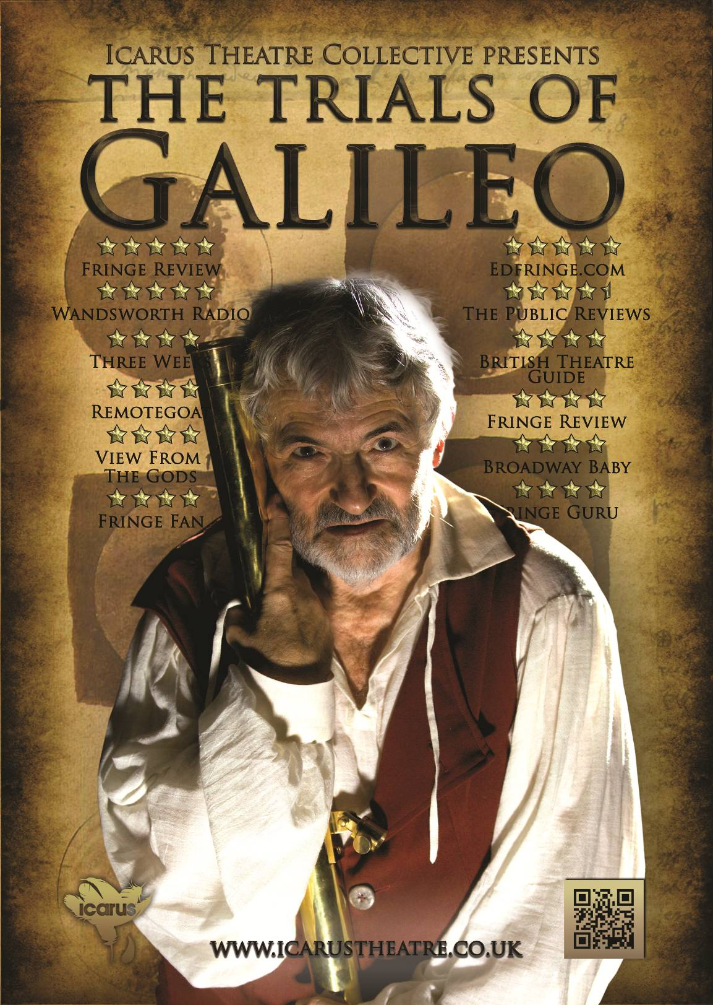

Journey’s End by R.C Sherriff
A co-production between Icarus Theatre Collective and
Original Theatre Company (2010)
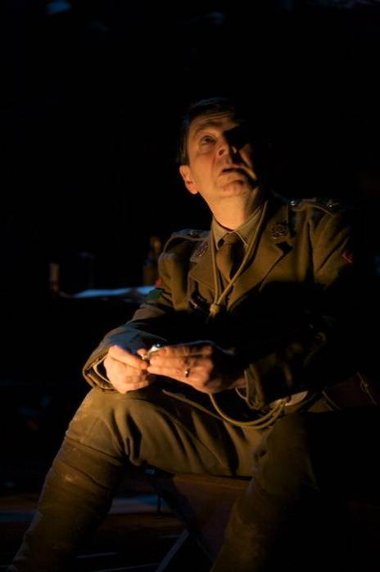
‘Strong and deeply moving… in Alistair Whatley's fine production there are outstandingly subtle, heartfelt performances’

Joyce MacMillan, Scotsman

‘Alastair Whatley taps into the playwright’s rhythms straightaway. He is blessed with a sterling ensemble’

Donald Hutera, The Times

‘Each and every performance is consummately delivered… this is a profound piece of theatre that highlights the heroism, humour and tragedy of warfare’

Steve Birbridge, The Public Reviews

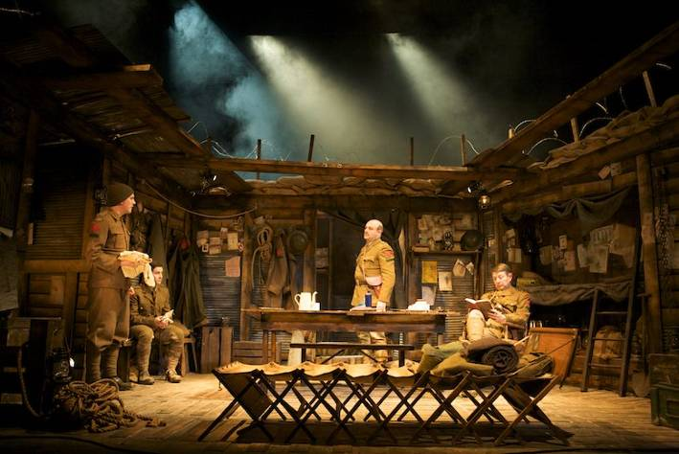
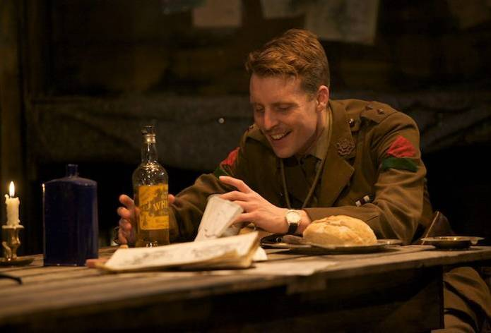

Vincent in Brixton by Nicholas Wright

A co-production between Icarus Theatre Collective and
Original Theatre Company (2009)
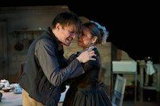
"Brooding, malevolent, marvelous and magnificent...it is a work of art"
-Paul Thomas, Bucks Free Press

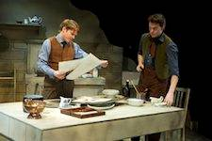
"It is rare to come across a show with such artistry, intelligence and talent and for that reason this is a must-see show. So far this is the play of the year and if patrons see nothing else this year, this is the show they need to see."
-Paul Bowers, Farnham Herald
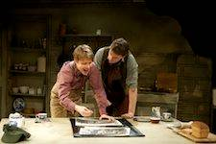

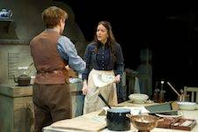
This play is a must-see -Anya Hastwell, Remote Goat
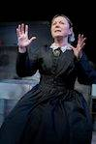
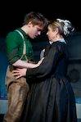

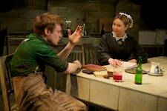
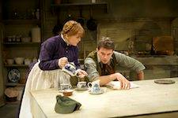
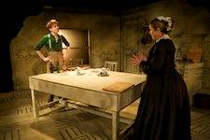

Macbeth by William Shakespeare
A co-production between Icarus Theatre Collective and
Harrogate Theatre (2011-2012)
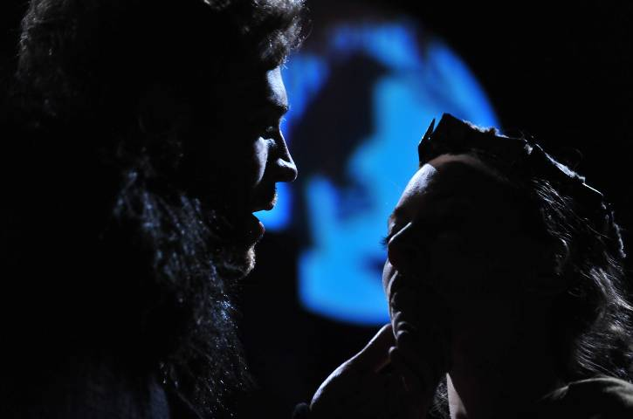
Remotegoat
Carrick Biz
Stage, Screen...
ThePublicReview
Oxford Theatre...
Three Weeks
"A remarkably high-octane Macbeth… as action packed as it is exhilarating… With sword, axe, spear and bare fist fighting it is an impressively energetic and dynamic production, wonderfully unhinged… don't miss it". -Victoria Claringbold, Remotegoat
"Five Stars alone are due to the designers of the simple set and the expressive mood-setting lighting and sound". -David Kerr, Carrick Biz
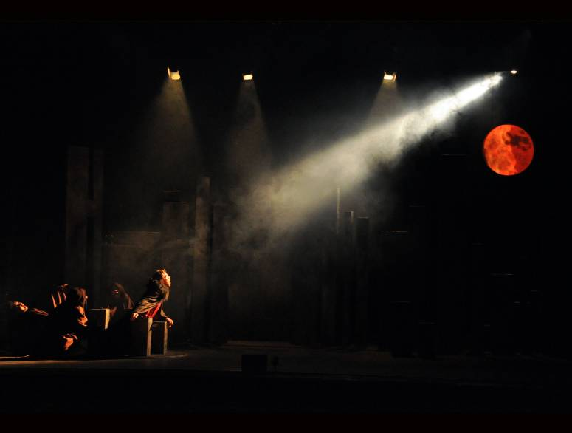
"Absolutely spine-tingling! … Go and see!" -Damien Bullen, Damowords
"Icarus Theatre Collective's Macbeth is an impressive fluid production… Clarity and adroit direction by Max Lewendel… The play explodes into action with a high-powered fight sequence using real swords, axes and spears that superbly captured the intensity of battle". -Robin Strapp, British Theatre Guide
"My heart missed a beat… An absolute thrill… Go see it". -G Allan, A Shakespeare Journey
The Lesson by Eugène Ionesco
The Icarus Theatre Collective in association with South Hill Park Arts Centre
Directed By Max Lewendel
International Tour
12 April 2007 - 07 April 2008
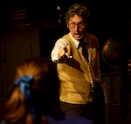
"Directed so specifically that the beast of chaos that charges through Ionesco's work like his own rhinoceros is safely routed through the play." -Rebecca Banks, Ham & High

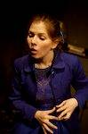
The Times

Won Special Jury Prize in Romania
Best Actress in a Leading Role – Amy Loughton in Romania

or better in 15 out of 17 reviews
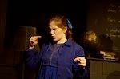
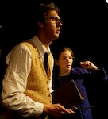

Othello by William Shakespeare
The Icarus Theatre Collective and Harrogate Theatre in association with the South Hill Park Arts Centre
Directed by Max Lewendel
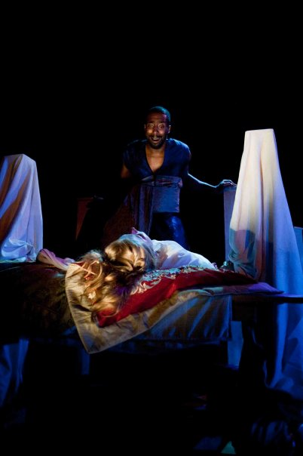
“This is a performance with music but not at all a musical. The strings catch the musicality of the text, although not every time an actor speaks. Turmoil and anxiety are heightened, passion brushed and coloured with a moment of melody. Then, when there is heightened dramatic tension, the instruments strike emphatic chords.”

Kevin Berry, The Stage

“Othello was a dramatic and spectacular show presented by Icarus Theatre Collective, Original Theatre Company and South Hill Park Arts Centre.”

Sonia Kapur,
The Maidenhead Advertiser

“Completely encapsulated, the audience, along with Othello, did indeed “lay down and roar’” for the tragedy of the deception. Both as actors and musicians, the level of talent was astounding.”

Alice Williams, The York Press
